Phase 1 · Design & Orient
Exercise 3: Architect First: Plan Mode and the Explore Agent
Dev cycle | Design (architecture)
CC features | Plan mode, the Explore subagent, @file references, reviewing a plan before code
Time | 30 min
You produce | An agreed architecture and file plan for ExpenseFlow, written to docs/ARCHITECTURE.md

Objective
The single biggest difference between amateur and professional AI-assisted development is planning before building. You will use plan mode to make Claude design the whole API on paper, critique the plan, and only then let it write a file. Nothing is built here, and that is the point.
Plan mode is cheap. Reviewing a plan takes 30 seconds; reverting wrong edits takes 30 minutes. Force a plan for anything past two files, every time, even when you think you don't need one.
Planning Mode is best for:
- Tasks requiring broad understanding of your codebase
- Multi-step implementations
- Changes that affect multiple files or components
Adjusting to a higher effort level is best for:
- Complex logic problems
- Debugging difficult issues
- Algorithmic challenges
Walk-through
1 | Enter plan mode
Press Shift+Tab until the mode indicator reads 'plan'. In this mode Claude cannot edit files: it can only think and propose. This is your design sandbox.
The mode indicator sits at the bottom of the Claude Code screen. Plan mode is also where Claude will route work to the read-only Explore agent for larger codebases.
Run /effort to see your current level and adjust it: low is faster and cheaper, max reasons longest on hard problems. The default depends on your model and plan — /effort shows you what yours is.
Press Shift+Tab until the mode indicator reads 'plan'. In this mode Claude cannot edit files: it can only think and propose. This is your design sandbox.
In plan mode only, read the existing plans/docs in this repo and synthesize a single normalized plan that reconciles overlaps and conflicts. Output one markdown plan that we will treat as the source of truth
Press Shift+Tab until the mode indicator reads 'plan'. In this mode Claude cannot edit files: it can only think and propose. This is your design sandbox.
In plan mode only, create a high-level implementation plan for adding <feature>. Break it into phases, list impacted files/folders, identify risks, and define a short ‘definition of done’. No code yet..
In plan mode only, create a high-level implementation plan for adding Email feature. Break it into phases, list impacted files/folders, identify risks, and define a short ‘definition of done’. No code yet..
VALIDATE The mode line shows plan mode. Try asking it to create a file: it will decline and offer a plan instead.

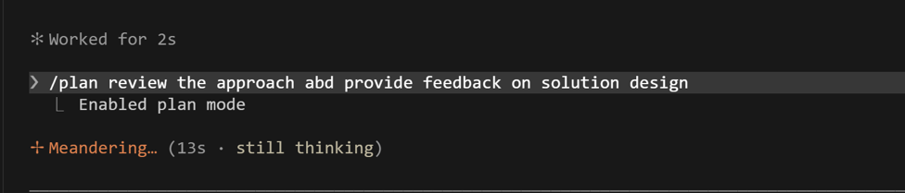
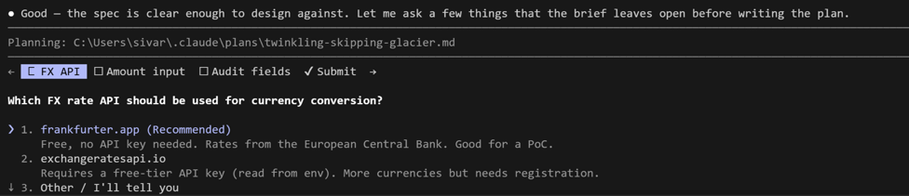
2 | Brief the architecture
Ask for a complete design, grounded in CLAUDE.md, with explicit data model and endpoints. Be demanding about edge cases now, while it is cheap.
Type this prompt into Claude Code
Design the architecture for ExpenseFlow per @CLAUDE.md. Produce:
1) the SQLite schema for an expenses table, with column types and why each exists,
2) the full list of endpoints with method, path, request body, and response,
3) the file layout and what lives in each file,
4) the three edge cases most likely to bite us, and how the design handles them.
Do not write code yet. Give me the plan.

VALIDATE You get a structured plan: an expenses table (id, description, amount_minor, currency, amount_base_minor, category, status, submitted_by, created_at), endpoints for create / list / get / approve / reject, and a file map matching CLAUDE.md.
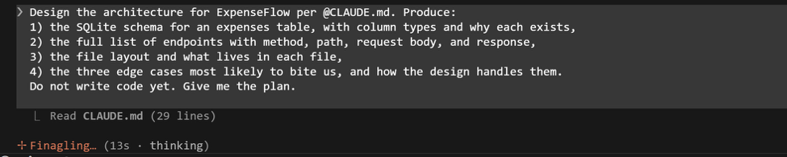
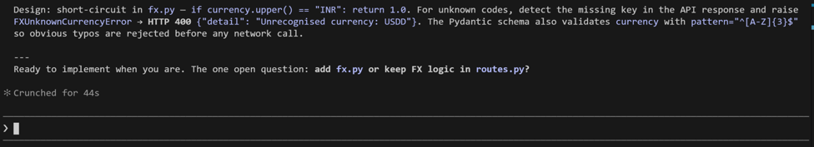

3 | Stress-test the plan
Do not accept the first plan. Push on the weakest point. A manager's job in AI-assisted development is asking the right questions, not writing every line.

Type this prompt into Claude Code
Two challenges. First: what happens to amount_base_minor if the FX API is down when an expense is submitted? Second: can an already-approved expense be approved again, and should the API allow that? Revise the plan to handle both.
VALIDATE The revised plan introduces a fallback or a 'pending conversion' state for FX failure, and a status guard so approve / reject are rejected on already-decided expenses. If it hand-waves either, push again.
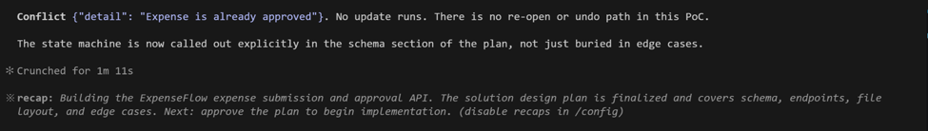

4 | Capture the plan to disk
Now leave plan mode (Shift+Tab back to normal) and have Claude write the agreed design into a docs file. This becomes your reference for the build phase and your handoff artefact later.
Type this prompt into Claude Code
Write the final agreed architecture to docs/ARCHITECTURE.md. Include the schema, endpoint table, file layout, and the edge-case decisions we just made.
VALIDATE Claude asks permission, then creates docs/ARCHITECTURE.md. Open it in VS Code and read it end to end: if you disagree with anything, fix it now, not after 200 lines of code exist.
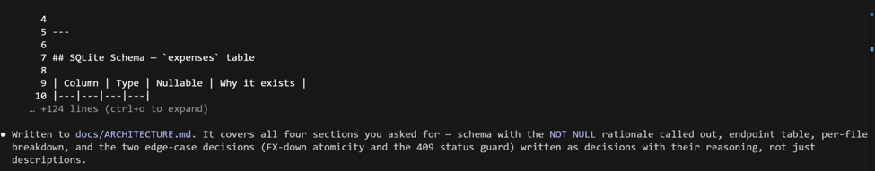
What success looks like
- A written, reviewed architecture exists before any application code.
- You forced at least two design decisions (FX failure, double-approval) instead of letting Claude pick silently.
- You can explain why the expenses table stores both amount_minor and amount_base_minor.
Common pitfalls (Windows and macOS)
- If you skip plan mode and just say 'build the API', Claude will make a dozen silent architecture choices you will spend Exercise 8 unwinding.
- @CLAUDE.md and @docs/ARCHITECTURE.md are file references: the @ pulls the actual file into context. Typos in the path mean Claude guesses.
Stretch goal
Ask Claude to use the Explore agent to scan the (currently small) repo and confirm the planned file layout does not clash with anything that exists. On a real codebase this read-only pass is how you onboard safely.

